**MISSAEL COLIN CUEVAS**

**EXTRA CREDIT #2**

PROBLEM 1.-

MATLAB Code:

clear; clc; close all

q0 = [0; 0];

h = 0.01;

t = 0:h:10;

A = [0 1;-5 -4];

B = [0; 1]

yexact = exp(-2*t).*(0.25*cos(t)-1.75*sin(t))-0.25*cos(3*t)+0.75*sin(3*t);

qstar = zeros(2,length(t));

qstar(:,1) = q0;

for i=1:(length(t)-1)

k1 = A*qstar(:,i)+B*(10*cos(3*(t(i))));

qstar(:,i+1) = qstar(:,i) + k1*h;

end

plot(t,yexact,'k-'), hold on, plot(t,qstar(1,:),'.');

legend('Exact','Euler');

title('Forced Mass Spring System');

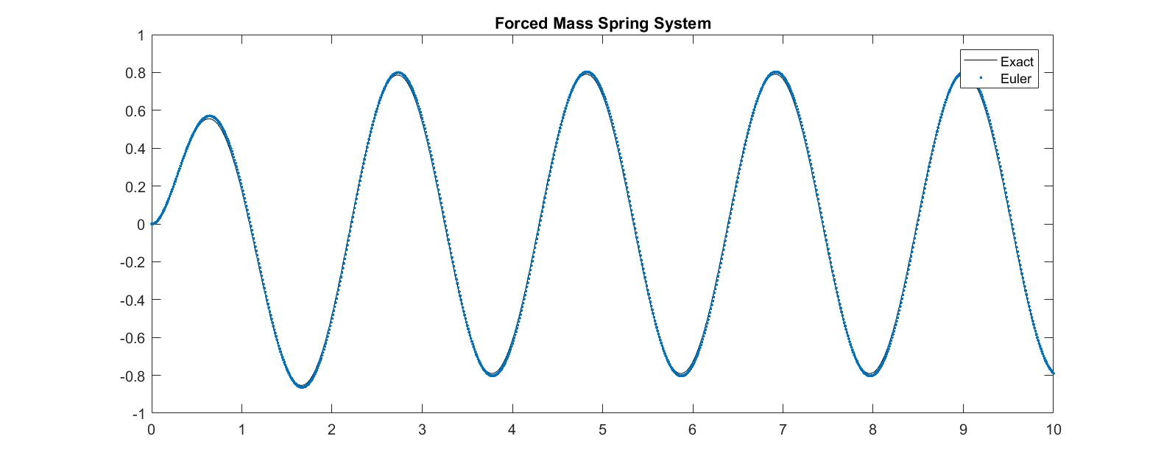hold off

PROBLEM 2.-

MATLAB code:

clear; clc; close all

q0 = [0; 0];

h = 0.005;

t = 0:h:100;

A = [0 1;-1 0];

B = [0; 1]

yexact = t.*sin(t)

qstar = zeros(2,length(t));

qstar(:,1) = q0;

for i=1:(length(t)-1)

k1 = A*qstar(:,i)+B*(2*cos(t(i)));

qstar(:,i+1) = qstar(:,i) + k1*h;

end

plot(t,yexact,'k-'), hold on, plot(t,qstar(1,:),'.');

legend('Exact','Euler');

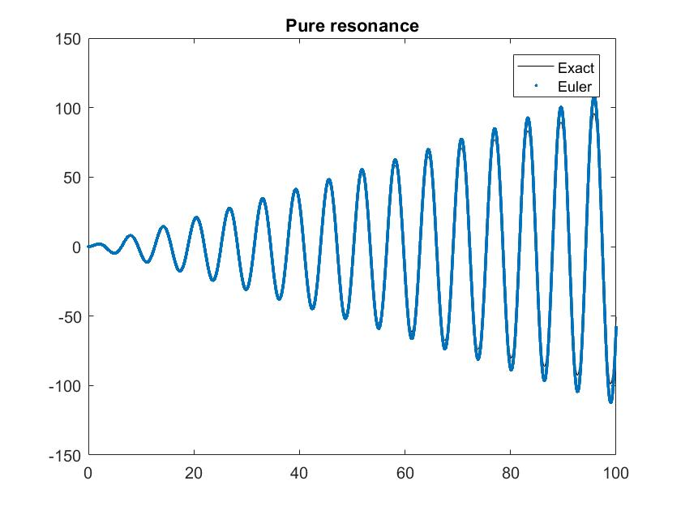title('Pure resonance');

hold off

PROBLEM 3.-

MATLAB code:

clear; clc; close all

q0 = [0; 0];

h = 0.00005;

t = 0:h:3;

A = [0 1;-484*pi^2 0];

B = [0; 1]

yexact = (1/(1848*pi.^2)).*(((sin(22*pi*t)).*(21*sin(2*pi*t)+sin(42*pi*t)))+(cos(22*pi*t)).*(21*cos(2*pi*t)+cos(42*pi*t)-22))

qstar = zeros(2,length(t));

qstar(:,1) = q0;

for i=1:(length(t)-1)

k1 = A*qstar(:,i)+B*(cos(20*pi*t(i)));

qstar(:,i+1) = qstar(:,i) + k1*h;

end

plot(t,yexact,'k-'), hold on, plot(t,qstar(1,:),'.');

legend('Exact','Euler');

title('Pure resonance');

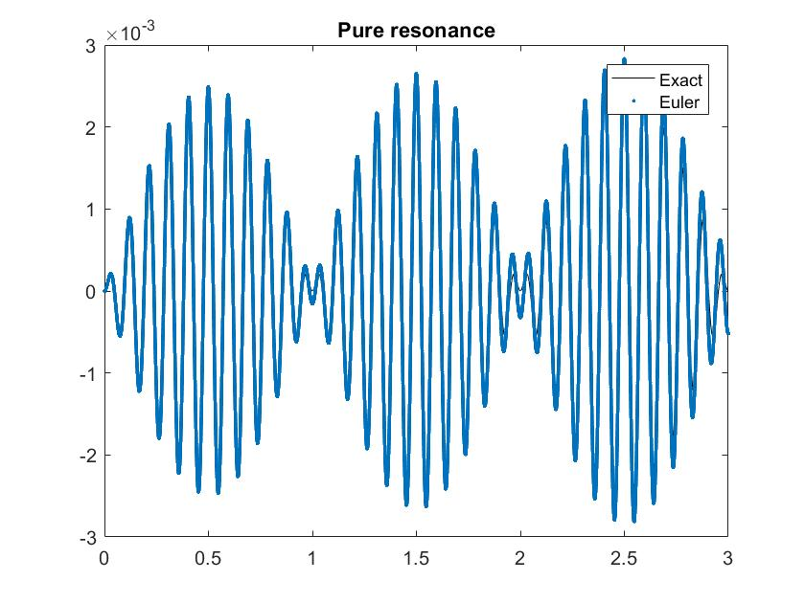hold off